**PROTOCOL:**

1. **Preparation**
   1. Procure electronic components needed to construct FED (**Table 1**).
   2. Print 3D designed components (available at: <https://github.com/KravitzLab/fed/wiki/Build-Instructions>). 3D-designed component dimensions and fit may vary depending on tolerance of the 3D printer.
   3. Download and install Arduino IDE (available at: <https://www.arduino.cc/en/Main/Software>) to program Arduino microcontroller.
   4. Download and install additional Arduino libraries to enable functionality of motor shield and data logger (available at: <https://github.com/KravitzLab/fed/>).
2. **Soldering electrical components**
   1. Arduino microcontroller and stackable shields:
      1. Solder stackable headers onto the top sides of the Arduino Pro and Adafruit data logging shield. Clip protruding wire from headers on the bottom of the Arduino Pro.

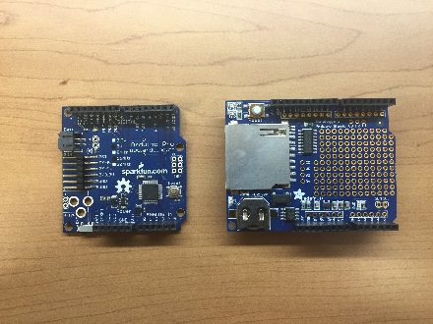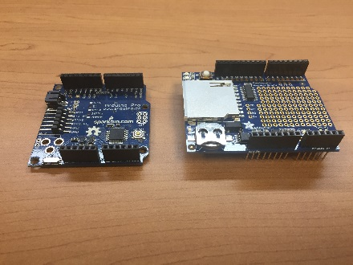

* + 1. Solder male headers onto an Arduino motor shield with pins protruding from the bottom. Create a ground line using a row on the prototyping area of the motor shield by soldering a piece of stripped wire from the peripheral ground (near D13) along the row of through holes.

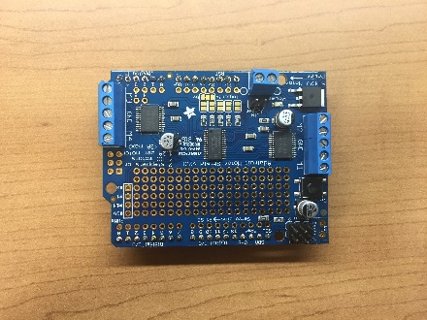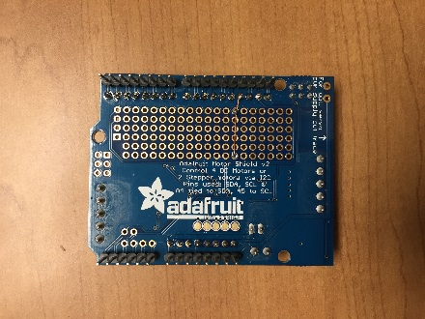

* 1. External power button:

Note: a latching metal pushbutton has five connections: power, ground, normally closed (NC1), normally open (NO1), and common (C1).

* + 1. Cut three wires 10 cm long each and one wire 2.5 cm long.
    2. Solder the 10 cm wires to power, ground, and C1. Add a small jumper wire to connect NO1 to the positive terminal—this schematic will illuminate the LED ring on the pushbutton when power is provided to the system. Heat shrink connections.

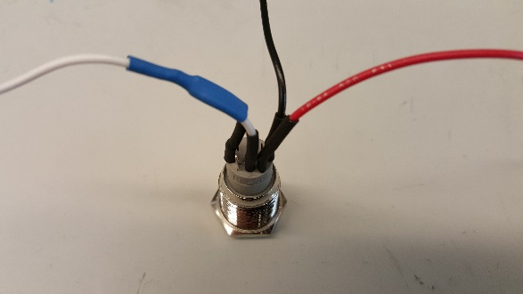

* 1. Photointerrupter:
     1. Solder photointerrupter to breakout board. Solder a 4.7kΩ resistor to the front of the breakout board.

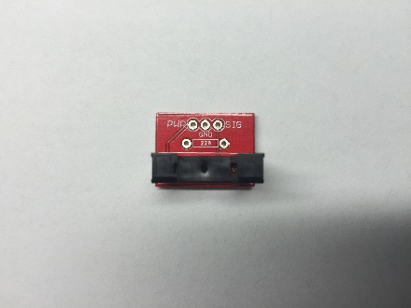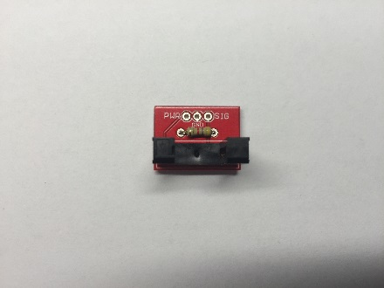

* + 1. Cut three wires 10 cm long and strip 0.5 cm off both ends of all wires. Solder these wires to the back of the breakout board (power, ground, and signal).

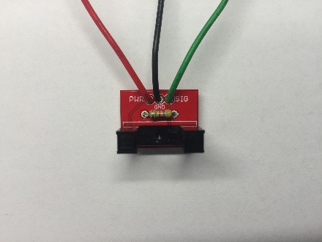

* 1. BNC output cable (optional):
     1. Cut two 7 cm wires with 0.5 cm stripped from both ends.
     2. Solder one wire to the signal connection of the BNC female chassis mount connector and heat shrink connection; solder the other wire to the outer ground ring.

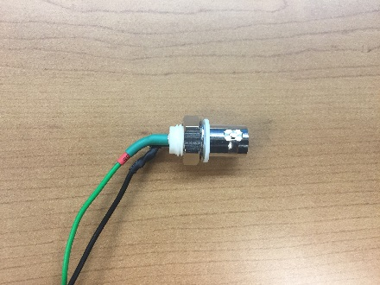

1. **Software upload**
   1. Stack Adafruit data logger shield on top of the Arduino Pro.
   2. Connect the Arduino board to a computer with an FTDI cable.
   3. Upload the RTC code to sync the current date and time (available at: <https://github.com/KravitzLab/fed/tree/master/fed-arduino>).
   4. Upload the FED sketch (available at: <https://github.com/KravitzLab/fed/tree/master/fed-arduino>).
2. **Hardware assembly**
   1. Stepper motor and Adafruit motor shield:

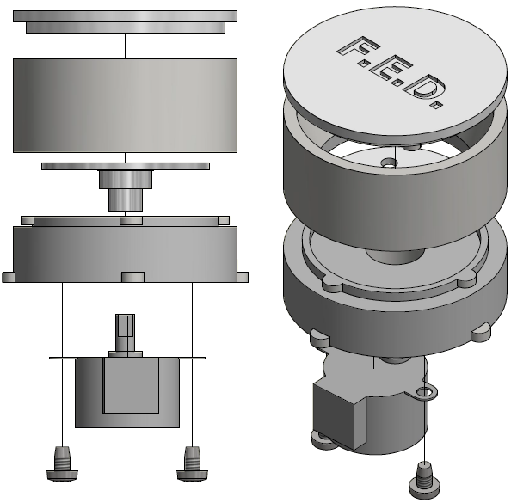

* + 1. Secure a 5V stepper motor onto the 3D printed motor mount with two self-drilling screws. Insert rotating disk into motor shaft and push down in place. Twist on 3D printed food silo onto the motor mount making sure the pellet leveler is aligned with the hole in the motor mount. Twist on connected pieces from above (steps 4.1.1 – 4.1.3) to the top of the printed base, with the stepper motor positioned towards the back of the base and the hole positioned in the front.

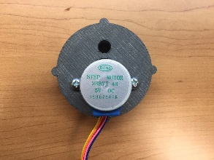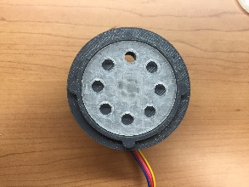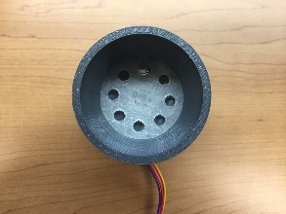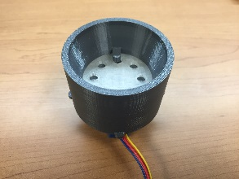

* + 1. Connect outputs from the 5-pin cable connector on the stepper motor to the terminal block connectors on the motor shield: red to ground, orange and pink to one motor port (e.g., M1), and blue and yellow to the other motor port (e.g., M2).

*Note:* Second argument in line Adafruit_StepperMotor*gPtrToStepper = gMotorShield.getSTepper(MOTOR_STEPS_PER_REVOLUTION,2); corresponds to which terminal block is used (1: M1, M2; 2: M3, M4).

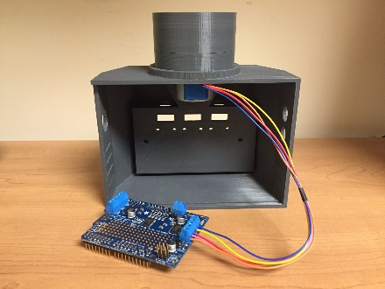

* 1. External power button:
     1. Insert power button from the outside in, on the right side of the 3D printed base. Secure button in place with hex nut.

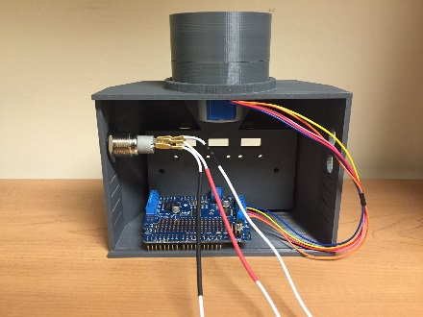

* + 1. Solder the end of the power wire to VCC of the microB USB breakout board.
    2. Solder the signal wire (C1) to Vin on the motor shield.
    3. Solder ground wire to the ground through hole on the motor shield (adjacent to Vin).
    4. Ground the microB USB breakout board to the Adafruit motor shield with a 10 cm wire.
  1. Photointerrupter:
     1. String the three wires from the photointerrupter (PWR, GND, and SGL) through the front middle hole of the 3D printed base. Insert photointerrupter arms through the back of the food well and secure in place with two nylon machine screws and hex nuts. Snap on 3D printed face place.

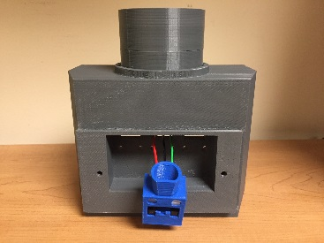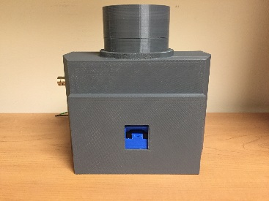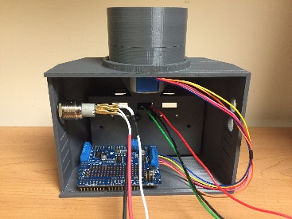

* + 1. Connect wires from the photointerrupter to the Adafruit motor shield: signal, power, and ground from the photointerrupter to D2, 5V, and GND on the motor shield, respectively.
  1. BNC output cable (optional):
     1. Insert BNC from the outside in on the left side of the 3D printed base. Screw ground ring and hex nut from the inside to secure in place.

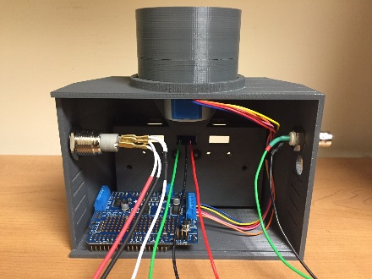

* + 1. Solder signal and ground wires from the BNC to D3 and ground on the motor shield, respectively.
  1. Battery:
     1. Connect a 3.7V battery pack to the Adafruit PowerBoost 500 Charger via the JST 2-pin connection
     2. Supply power to the system by connecting the PowerBoost to the microB USB connection on the breakout board via a USB cable.
  2. 3D printed FED components:
     1. Stack Adafruit motor shield on top of Arduino pro and data logger shield.
     2. Arrange electronic components into the 3D printed base and close with back cover.

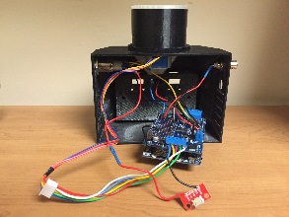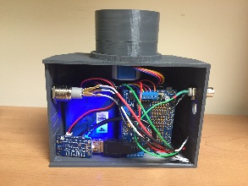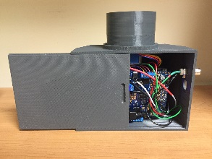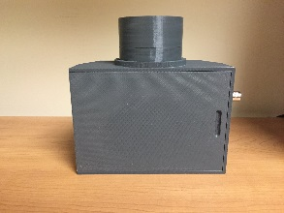

* + 1. Fill food silo with desired sized food pellets (20 or 45 mg, depending on the disk used) and cap.

1. **Validation and data acquisition**

Note: Prior to powering on a FED system, ensure a coin battery and SD card are inserted into their respective slots on the SD shield, and the VIN jumper is connected on the motor shield; otherwise FED will not dispense pellets.

* 1. Power on FED system with the power pushbutton and test device functionality by hand:
     1. Manually remove 5-10 pellets from food well and confirm that replacement pellets are dispensed.
  2. Remove SD card and verify that data was logged properly. Data should be acquired in a comma-separated value (.CSV) file named according to the date and start time of each device.
  3. Place FED unit inside experimental setting and power on. Ensure that a pellet is dispensed into the food well.
  4. Over the course of data acquisition, check FED daily to verify that it is working properly by:
     1. Confirming that the LED light on the power switch is on, indicating that the battery is not dead.
     2. Confirming that a pellet is sitting in the food well
  5. After data acquisition, retrieve SD card.
  6. Analyze data using custom-built analysis scripts, or using open-source Python codes (available at: <https://github.com/KravitzLab/fed/>).

|  |  |  |  |
| --- | --- | --- | --- |
| **Name of the Material/Equipment** | **Company** | **Catalog Number** | **Quantity** |
| Arduino Pro 328 - 5V/16MHz | SparkFun | DEV-10915 | 1 |
| Shield stacking headers for Arduino (R3 Compatible) | Adafruit | 85 | 2 |
| Adafruit Assembled Data Logging shield for Arduino | Adafruit | 1141 | 1 |
| SD/MicroSD Memory Card (8GB SDHC) | Adafruit | 1294 | 1 |
| Adafruit Motor/Stepper/Servo Shield for Arduino v2 Kit - v2.3 | Adafruit | 1438 | 1 |
| Metal Pushbutton - Latching (16mm, Red) | SparkFUn | COM-11971 | 1 |
| Photo Interrupter - GP1A57HRJ00F | SparkFun | SEN-09299 | 1 |
| SparkFun Photo Interrupter Breakout Board - GP1A57HRJ00F | SparkFun | BOB-09322 | 1 |
| Resistor Kit - 1/4W | SparkFun | COM-10969 | 1 |
| 50 Ohm BNC Bulkhead Jack (3/8" D-Hole) | L-com | BAC70A | 1 |
| FTDI Friend + extras - v1.0 | Adafruit | 284 | 1 |
| USB cable - 6" A/MicroB | Adafruit | 898 | 1 |
| Small Reduction Stepper Motor - 5VDC 32-Step 1/16 Gearing | Adafruit | 858 | 1 |
| Drilling Screw, #6-20x1/2 | Grainger | 2DU89 | 2 |
| SparkFun microB USB Breakout | SparkFun | BOB-12035 | 1 |
| PowerBoost 1000 Charger | Adafruit | 2465 | 1 |
| Lithium Ion Battery Pack - 3.7V 6600mAH | Adafruit | 353 | 1 |
| Multi-Colored Heat Shrink Pack - 3/32" + 1/8" + 3/16" | Adafruit | 1649 | 1 |
| Hook-up Wire Spool Set - 22AWG Solid Core - 6x25ft | Adafruit | 1311 | 1 |
| Nylon Mach Screw, Flat, 10-24 x 1 L | Grainger | 2HU62 | 2 |